How to Apply for Graduate Housing

Apply for Housing:
Starting Wednesday, April 20, 2022, 9:00 am EST, go to your Self Service portal or go to https://housing.yale.edu and log into Self Service with your Yale NetID and password. You will not see the housing application until it goes live on April 20 at 9 am.

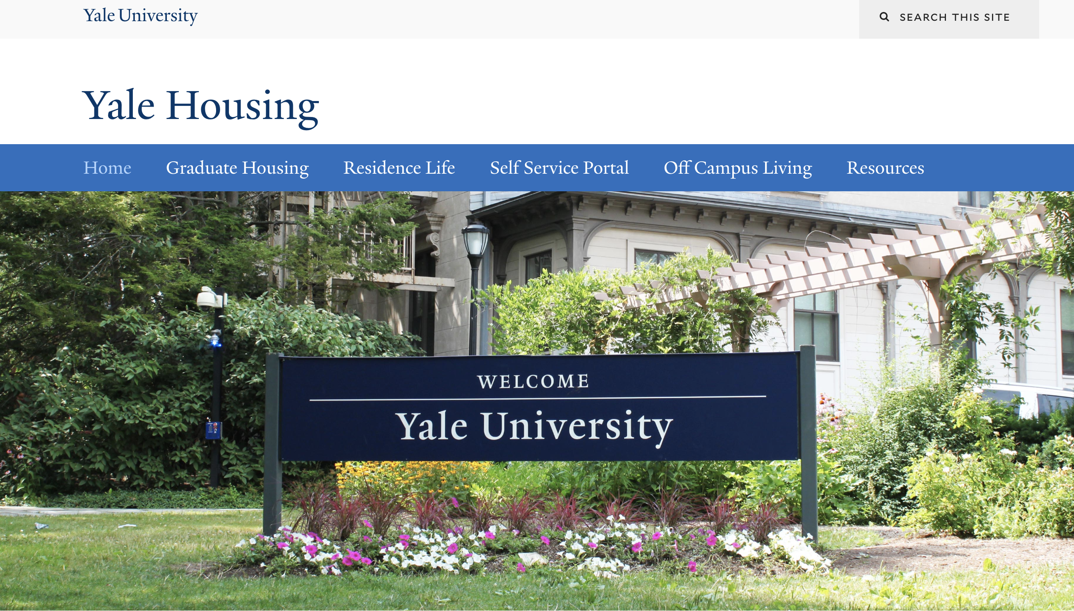

Click Applications from drop-down menu on the left-hand column, select 2022-2023 Graduate Housing Application. Complete the Housing Application and hit the Continue button to submit.

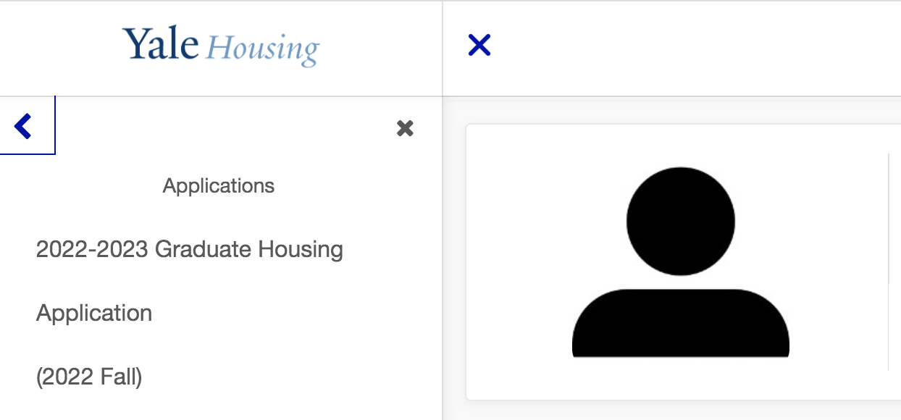

You will be asked what kind of housing are you seeking?
- Dorms
- Apartments
- Family Housing

Choosing Dorms or Apartments, you will automatically be entered into Room Selection once you submit the Housing Application.

Family Housing applicants – you will be contacted by someone from the Housing Office regarding an assignment at Whitehall or Esplanade.

Room Selection for Dormitory and Apartment Applicants

Instructions for picking your room for 2022-2023 Academic Year:

- Once you submit your application, click the Home button or log back into your Self Service. You will see the Room Selection:

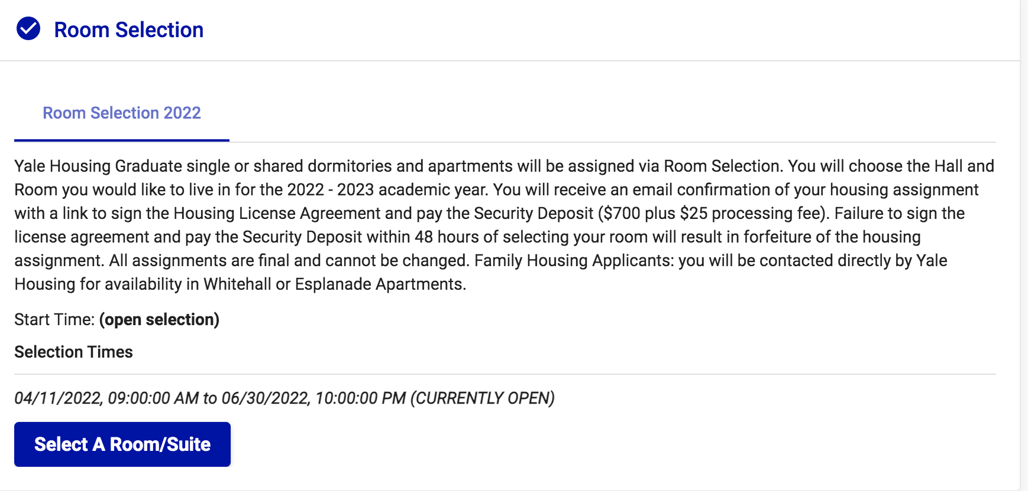

Click on the blue button Select a Room/Suite.
You will be able to filter by Hall. Or, you can search through all available rooms.

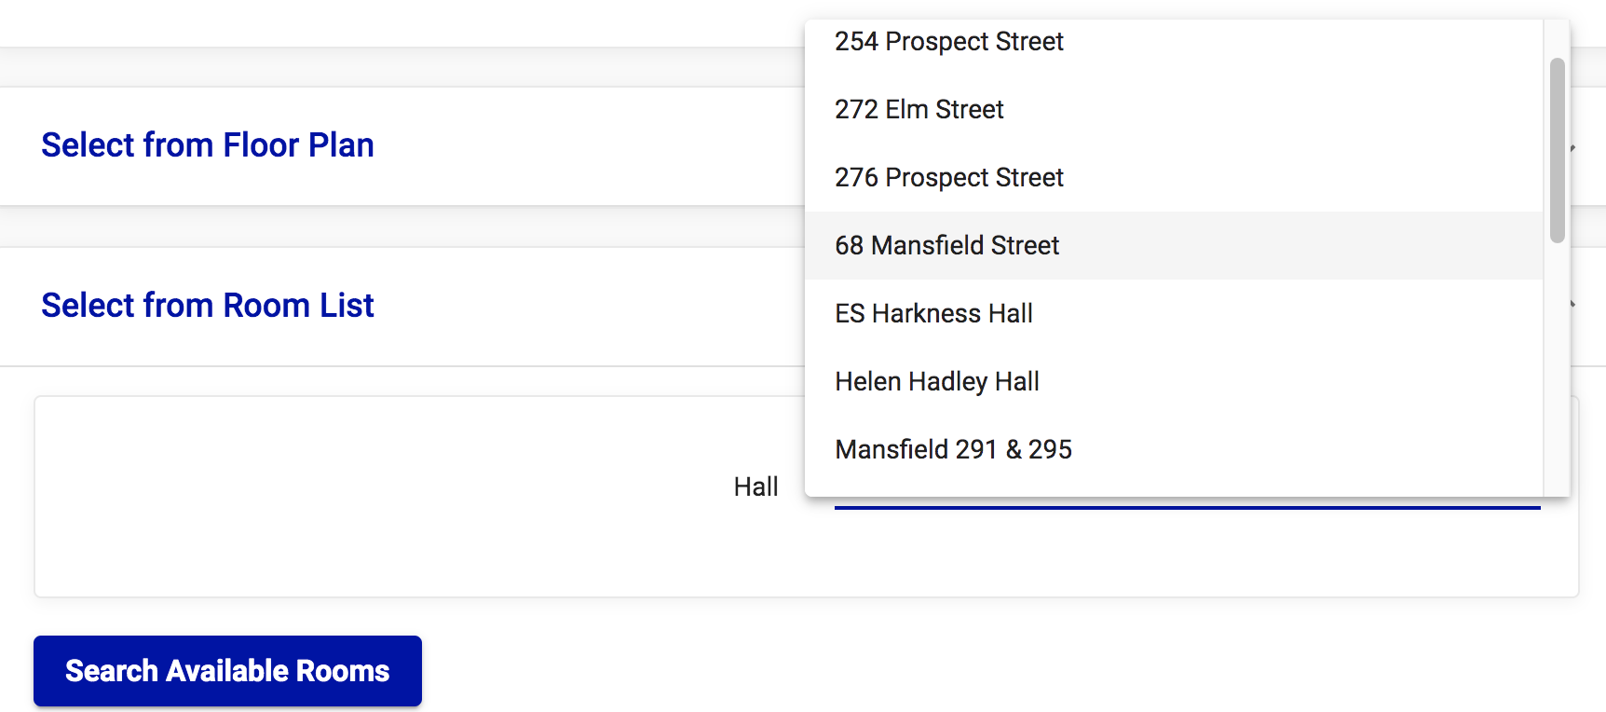

Using Helen Hadley Hall as an example to filter, you will see all available rooms at HHH:

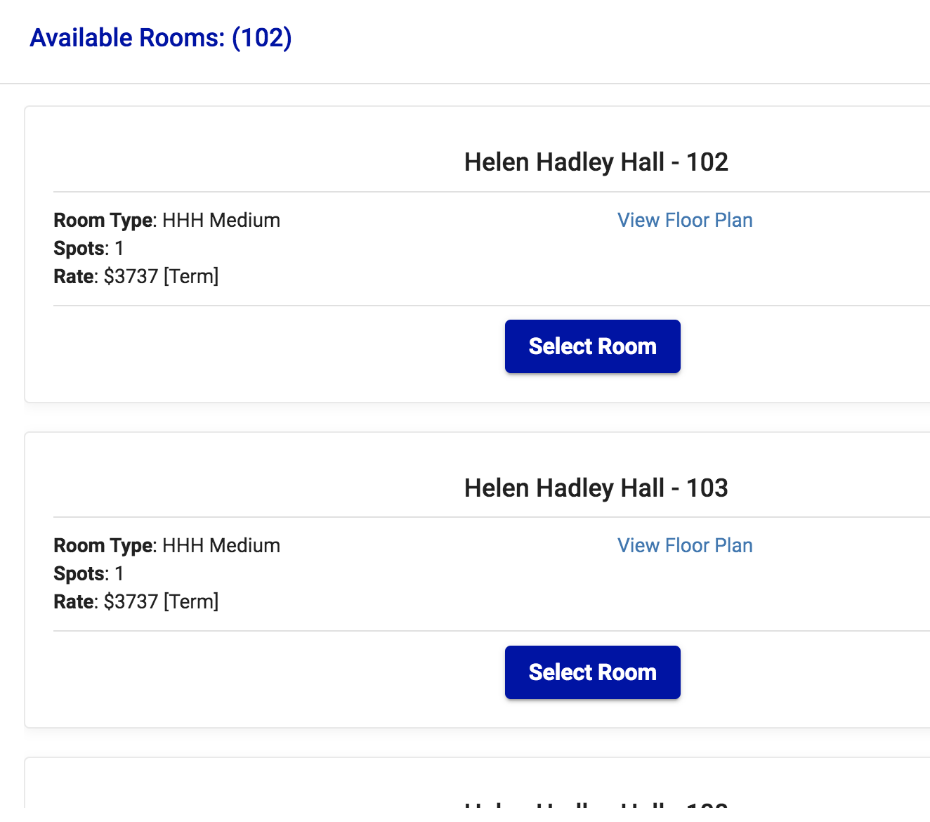

Once you’ve decided on a room, click the Select Room button. You will get this message:

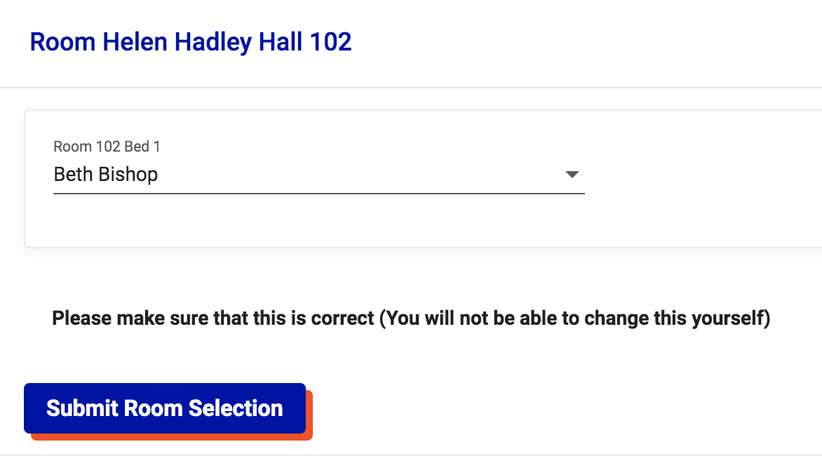

Click Submit Room Selection.

You will then get an email confirmation. Please check your junk folder if you don’t see it.

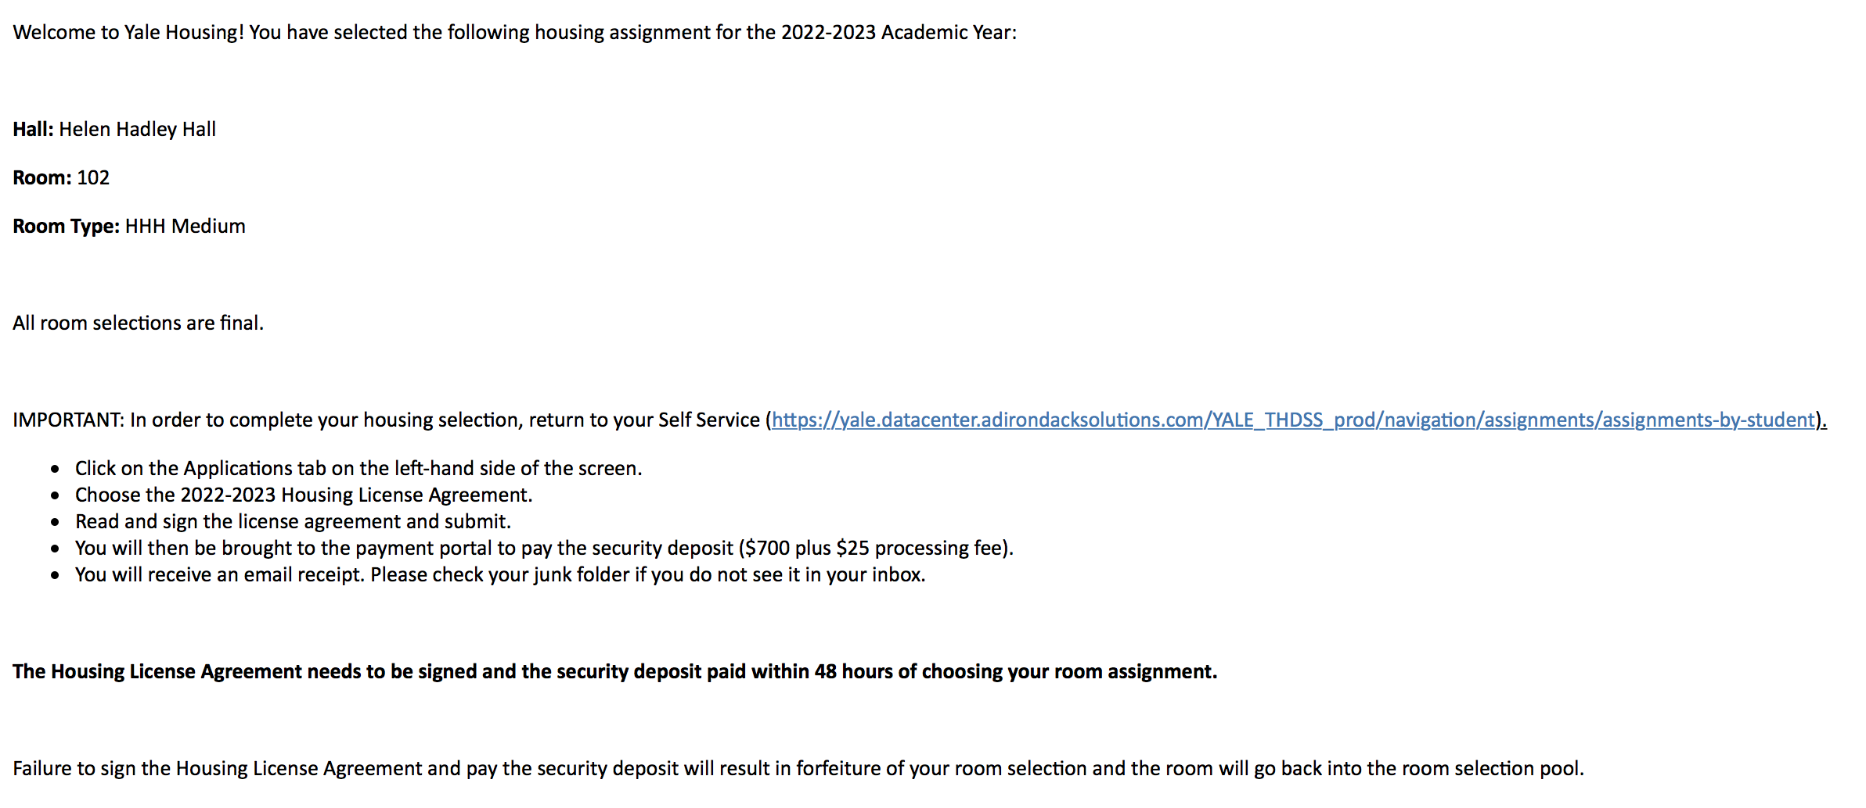

To finalize the room selection, you will need to sign the license agreement and pay the Security Deposit ($700 plus $25 processing fee) Under the Applications tab, choose 2022-2023 Housing License Agreement (Fall 2022). Read and sign the Housing License Agreement at the bottom where indicated.

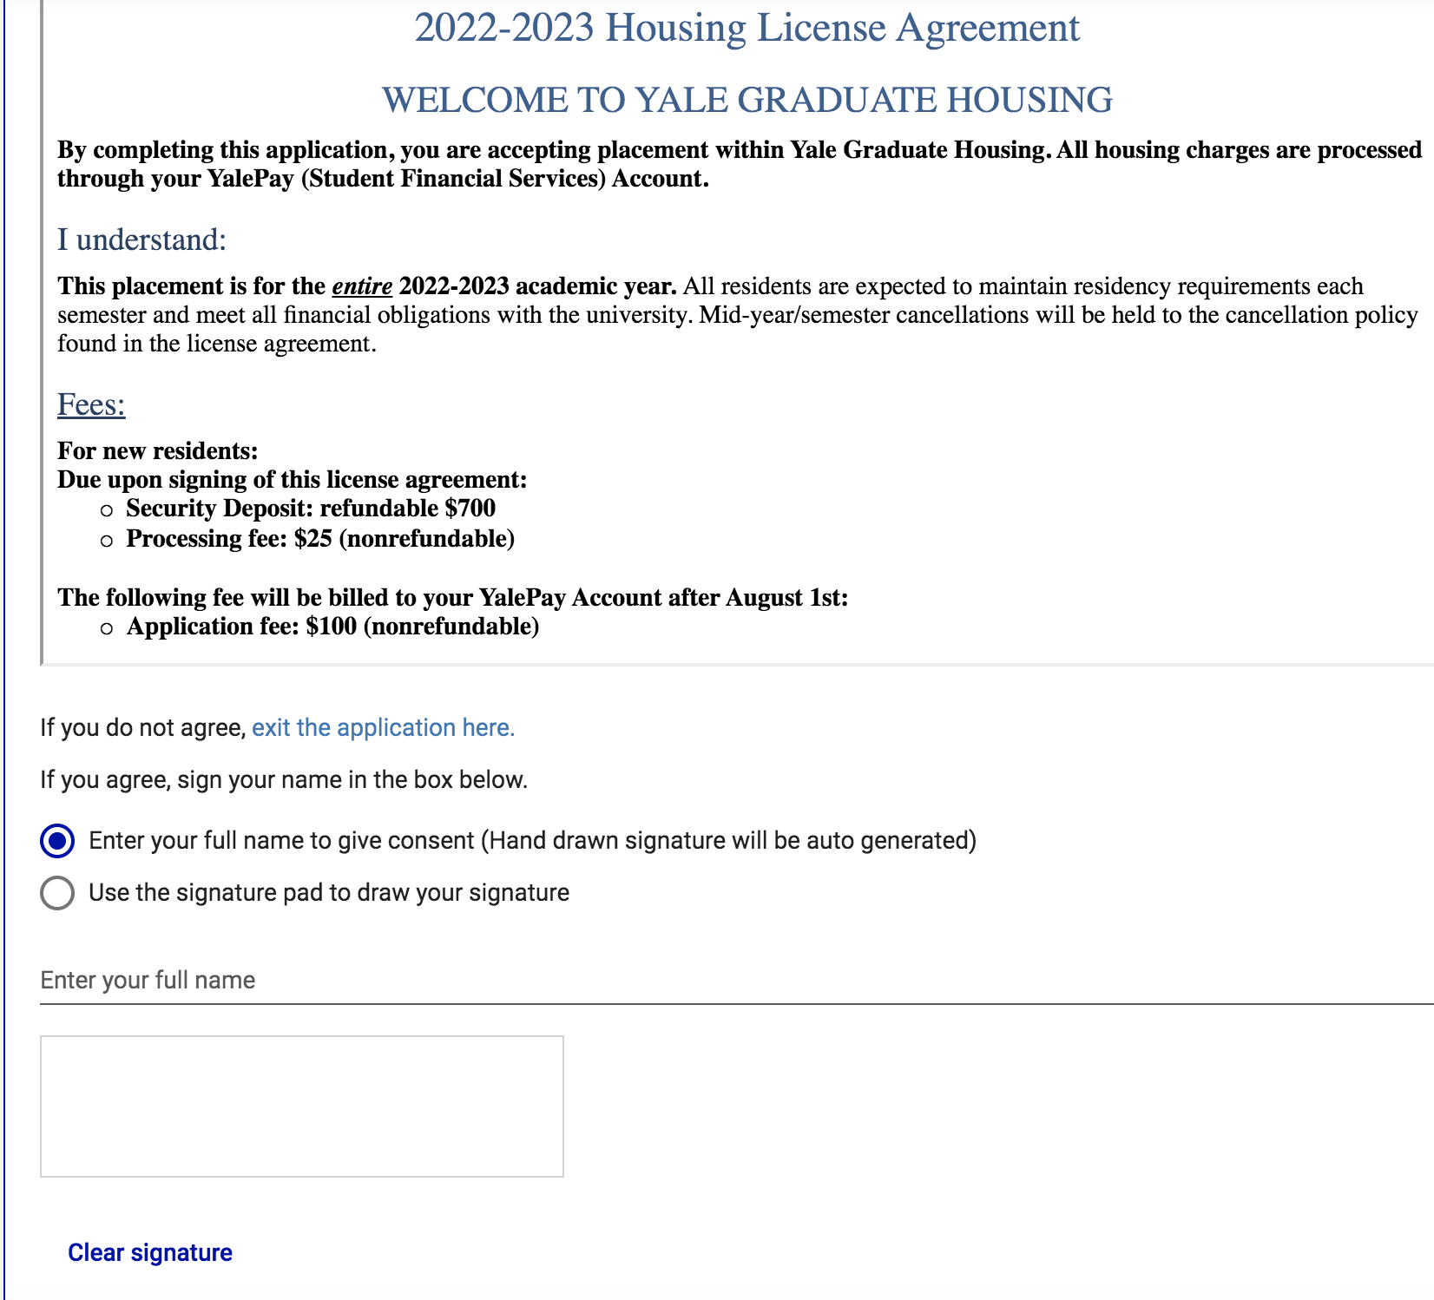

Once you sign and submit the housing license agreement, you will be brought to the Emergency Contact page:

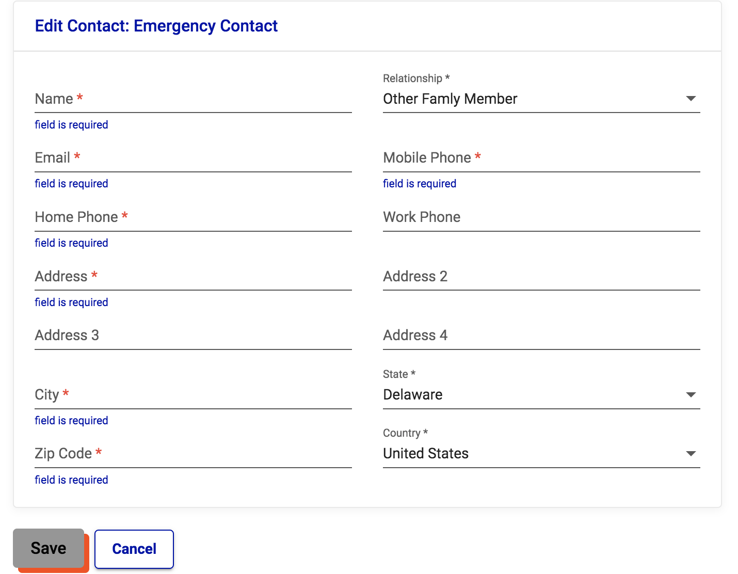

Once you click Save, you will be brought to the secure online payment portal where you will pay the $700 Security Deposit (plus $25 processing fee).

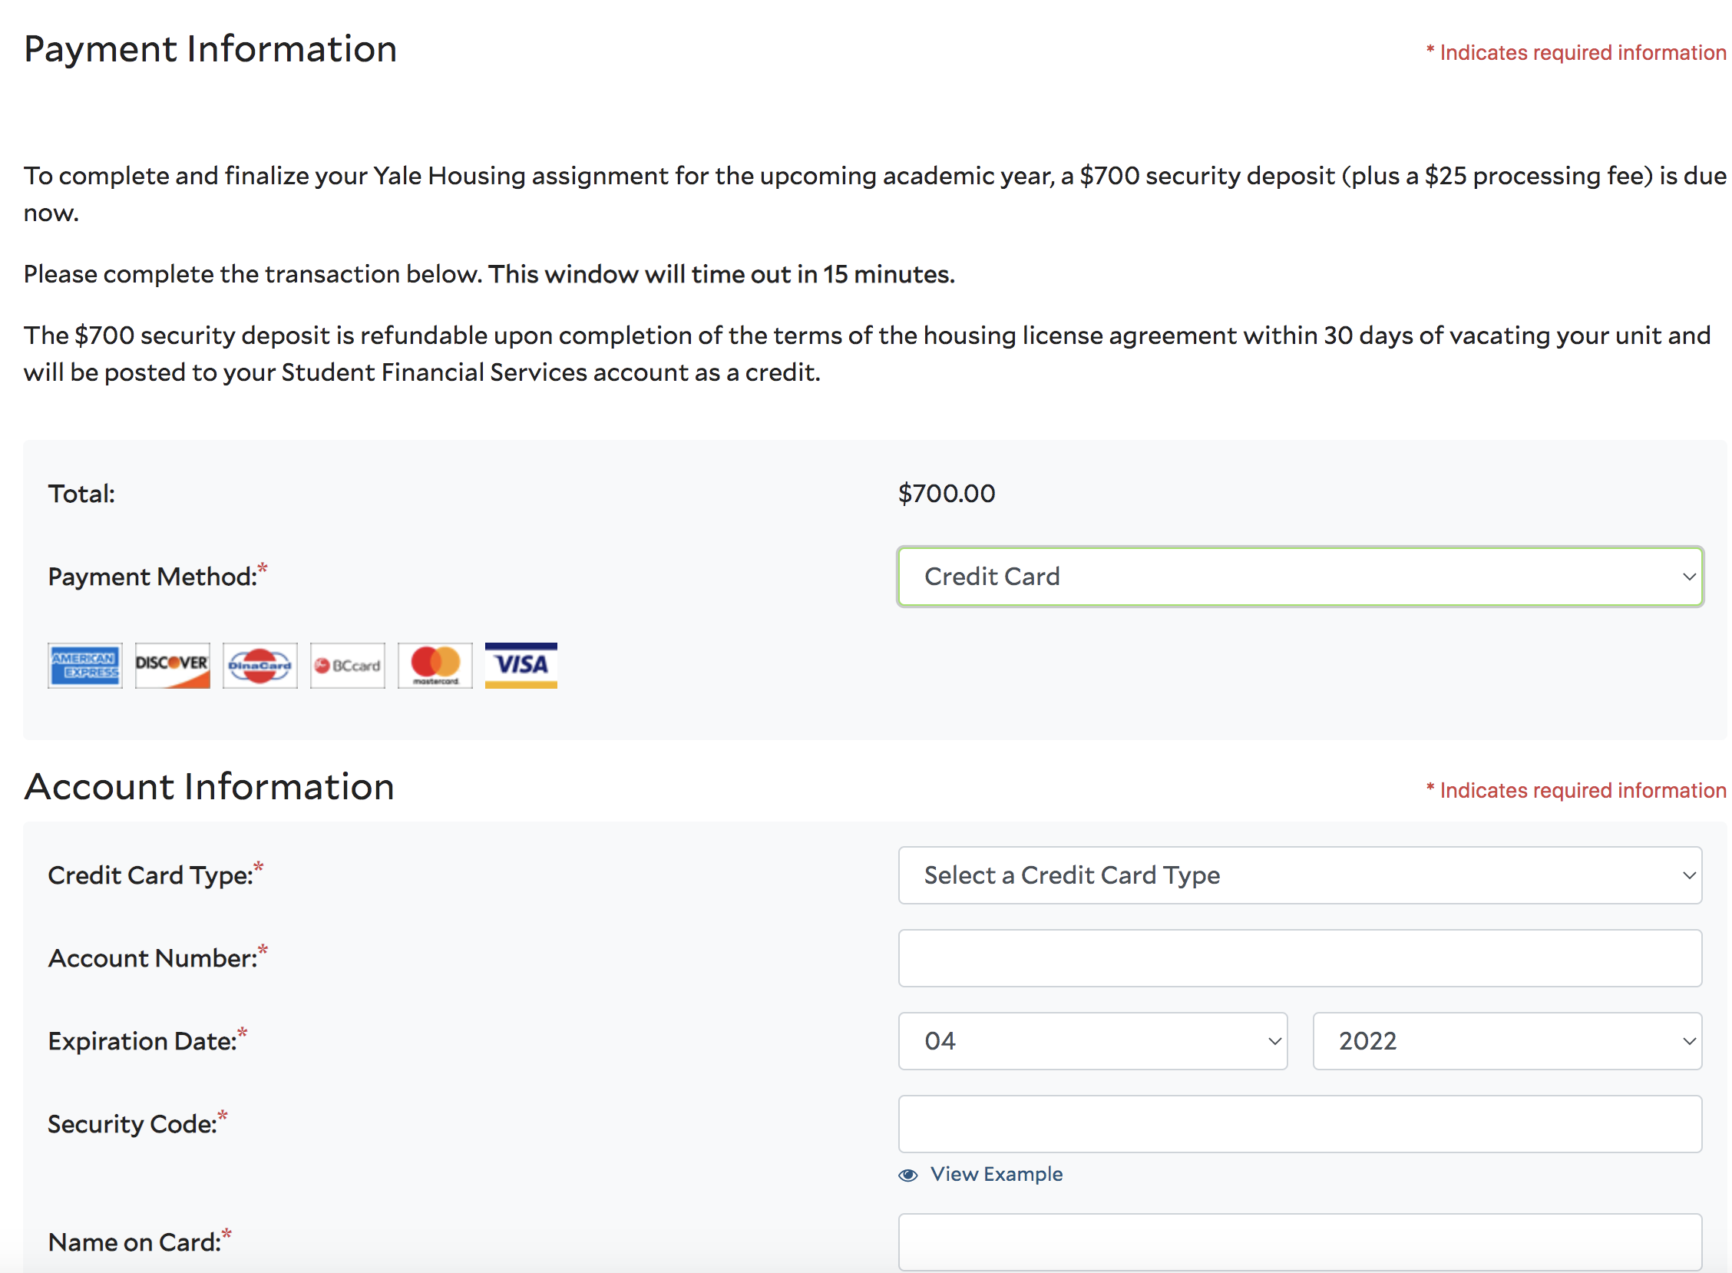

You’ll receive an email confirmation that you have paid your security deposit. Please check your spam or junk folder if you don’t see it in your inbox.

What you need to know:
- All chosen assignments are final. If you want to cancel your room, you need to contact the Housing Office (housing@yale.edu).
- If you cancel your assignment, you will forfeit the $700 security deposit.
- Housing assignments without a signed housing license agreement or security deposit will be withdrawn and put back into room selection after 48 hours.

